**MASK DETECTOR**

**Project Synopsis**

**INDUSTRIAL TRAINING (ECS-591)**

**BACHELOR OF TECHNOLOGY CSE (IBM)**



|  |
| --- |
|  |

**FACULTY OF ENGINEERING AND COLLEGE OF COMPUTING SCIENCES (FOECS)**

**TEERTHANKER MAHAVEER UNIVERSITY (TMU), MORADABAD**

PROJECT GUIDE: SUBMITTED BY:

**Dr. R.C. Tripathi Sambhav Jain (TCA1857005)**

**PROF. FOECS (TMU) B.TECH CSE (IBM) 3rd Year**

Table of Contents

1 Project Title 3

2 Domain 3

3 Problem Statement 3

4 Project Description 3

4.1 Scope of the Work 4

4.2 Project Modules 4

5 Implementation Methodology 4

6 Technologies to be used 5

6.1 Software Platform 5

6.2 Hardware Platform 5

6.3 Tools 5

Webcam 5

7 Advantages of this Project 6

8 Future Scope and further enhancement of the Project 6

10 Conclusion 6

11 References 7

# Project Title: MASK DETECTOR

**INTRODUCTION**: The Project is named as “Mask Detector”. It is named this because in this we have actually used the Pretrained Model of Transfer Learning to Train our Model and then it will help us to do the Mask Detection. **Transfer learning** (TL) is a research problem in machine learning (ML) that focuses on storing knowledge gained while solving one problem and applying it to a different but related problem. To deal with the lack of data, we make use of a technique called transfer-learning. This reduces the need for data related to the specific task we are dealing with.

# Domain:

In this project we used the pretrained Model of Transfer Learning i.e. VGG16 or Mobilenet. This falls in the category of detection and recognition domain. I have used the library i.e. TensorFlow used for numerical computation and large-scale machine learning. Keras is the module of TensorFlow.

# Problem Statement:

In this pandemic situation it is very necessary to ensure that people are following the guideline issued by the government to prevent the spread of Coronavirus. One of them being wearing masks in public places to reduce the transmission by preventing the virus from getting into from your nose and mouth. So, this project could be a great initiative to ensure that a person is wearing mask and also establishing the safety of others in public places.

# Project Description:

The project consists of Pre-trained model of Transfer Learning that is VGG16 orMobileNetV2, Dataset which contain Mask and Without mask class images and haar cascade file which uses live webcam to easily identify whether a personis Wearing mask or not.

Firstly, we collected the dataset of individuals and divided them into two classes i.e. with mask or without mask. then we imported all the required libraries and pretrained model which we used in this project and after that we convert our images in 224*224 frame because our pretrained model only works on this specified image size. And then we used some layers and activation function by which we epoch our trained dataset and made our model work with better accuracy. Then after that we use this trained model by loading it and then we wrote our image prediction code by which we predicted whether the person is wearing mask or not. We can also by load the same model in video prediction code by which we can access our live webcam with the help of haar cascade filewhere we used live webcam which helped us to detectwhether the person is wearing mask or not through live real time video processing.

## Scope of the Work:

This project will help us to monitor the implementation of COVID-19 guidelines issued by the government in public places. It uses pre trained transfer machine learning model and classification algorithm to identify whether a person is wearing mask or not. This project will also help in ensuring the safety of the individuals in public places.

## Project Modules:

The Project Modules are as follows:

1. Dataset – It contain a two type of classes which name are with mask or without mask images. By using this dataset we can train our model.
2. Classification – by using our train model when we open a camera it will detect/classify our model in two categories which are labeled as mask or without mask.

# Implementation Methodology:

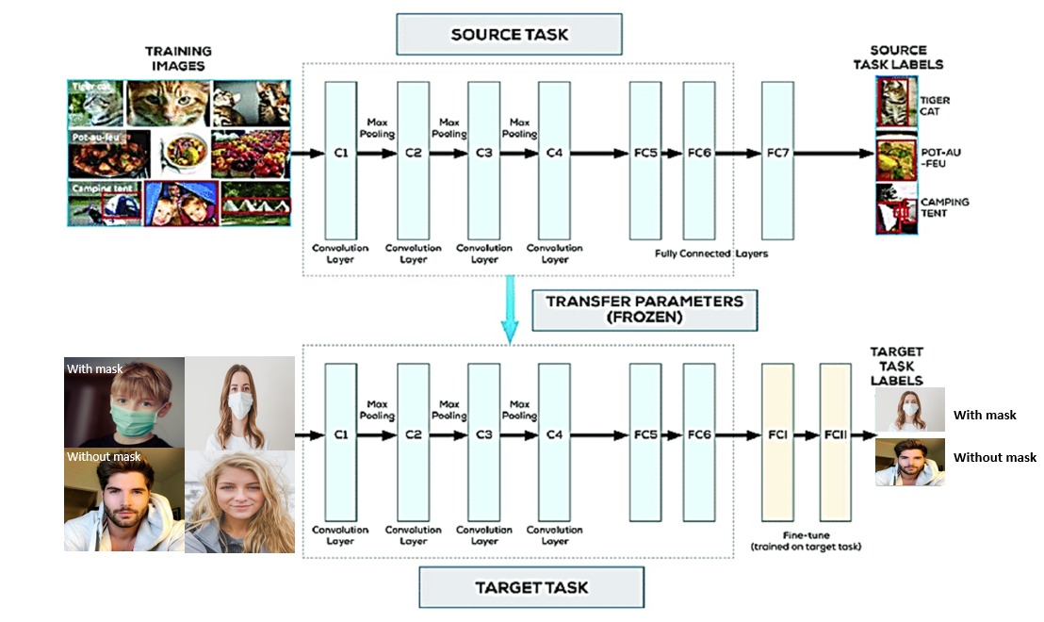

*Fig.1: Implementation Architecture*

1. First we install the required library according to our project.

2. Then we check our dataset which contain mask or without mask images.

3. Then we process our data like data preprocessing and pass our data according to our project.

4. Then we trained our dataset by using some deep learning algorithm in which we use some layers and activation function.

5. Then after that we check our model accuracy and save our model.

6. Then we use our model and implement on real time camera.

7. Then finally we got our final result it detects the mask or without mask.

# Technologies to be used:

## Software Platform:

1. **Front-end**

UI with built in camera which captures the live video to detect whether an individual is wearing mask or without mask.

1. **Back-end:**

Pre-trained model on the basis of transfer learning and classification algorithm which is trained to detect whether the person is wearing mask or not.

## Hardware Platform

**RAM**: at least 4GB,

**Hard Disk**: 500 GB,

**OS**: Windows 10 or Linux,

**Editor**: Jupyter Notebook or Spyder

**Browser**: Google chrome

## We need WebCam

# Advantages of this Project:

* Mask Detector.
* Limits the Spread of coronavirus.
* Ensures safety of people in public places.
* Helps government to regulate COVID-19 guidelines.

# Future Scope and further enhancement of the Project:

With further improvements these types of models could be integrated with CCTV or other types cameras to detect and identify people without masks. With the prevailing worldwide situation due to COVID-19 pandemic, these types of systems would be very supportive for many kinds of institutions around the worldit easier to deploy the model to embedded systems (Raspberry Pi, Google Coral, etc.).This system can therefore be used in real-time applications which require face-mask detection for safety purposes due to the outbreak of Covid-19. This project can be integrated with embedded systems for application in airports, railway stations, offices, schools, and public places to ensure that public safety guidelines are followed.

9 Reports

# Conclusion:

Hence, we successfully created a “**MASK DETECTOR**” using a pretrained model. It is based on transfer learning and classification algorithm. This model is successfully able to detect whether a person is wearing a mask or not. This project could be very useful and helpful for the government to implement Covid-19 Guidelines to ensure the safety of the citizen in public places.This system can therefore be used in real-time applications which require face-mask detection for safety purposes due to the outbreak of Covid-19.

# References:

## Website:

1. <https://analyticsindiamag.com/a-practical-guide-to-implement-transfer-learning-in-tensorflow/>
2. <https://docs.opencv.org/2.4/modules/highgui/doc/reading_and_writing_images_and_video.html>
3. <https://docs.opencv.org/3.4/d7/d8b/tutorial_py_face_detection.html>
4. <https://youtu.be/Ax6P93r32KU>
5. <https://github.com/chandrikadeb7/Face-Mask-Detection>
6. <https://tryolabs.com/blog/2020/07/09/face-mask-detection-in-street-camera-video-streams-using-ai-behind-the-curtain/>
7. <https://developer.nvidia.com/blog/implementing-a-real-time-ai-based-face-mask-detector-application-for-covid-19/>

## Books:

1. <http://web.stanford.edu/class/cs20si/lectures/march9guestlecture.pdf>
2. <https://arxiv.org/abs/1801.04381>
3. <https://www.pdfdrive.com/tensorflow-books.html>
4. <http://uu.diva-portal.org/smash/get/diva2:601707/FULLTEXT01.pdf>
5. <https://www.researchgate.net/publication/329557776_A_Haar_Classifier_Based_Call_Number_Detection_and_Counting_Method_for_Library_Books>
6. <https://www.researchgate.net/publication/227173993_The_Performance_of_the_Haar_Cascade_Classifiers_Applied_to_the_Face_and_Eyes_Detection>
7. <https://ieeexplore.ieee.org/document/8888092>
8. <https://link.springer.com/chapter/10.1007/978-3-540-73007-1_85>